**STAT 40001/STAT 59800 Statistical Computing Fall 2020**

**Lab -16**

1. In order to find the relationship between the number of hours student study outside the class and their test score we have collected a sample of 10 students and observe their test score and the number of hours they spend outside the classroom.

Student Score # of hours/Week

Andrea 63 3

Ben 79 11

Randy 53 8

Jamie 77 10

Emily 89 13

Darryl 66 5

Joseph 64 4

Eleanor 91 14

Jacob 71 5

Sharon 74 9

1. Calculate the Pearson correlation coefficient.

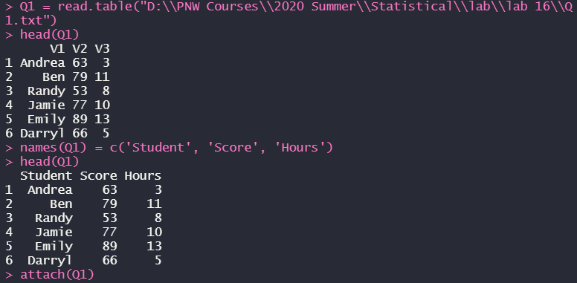



1. Calculate the Spearman correlation Coefficient



1. Calculate the Kendall’ s Tau.



1. Using each method test the hypothesis that the correlation is nonzero.

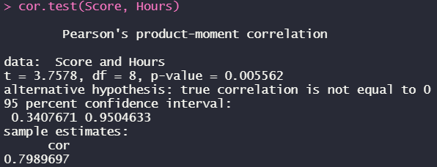

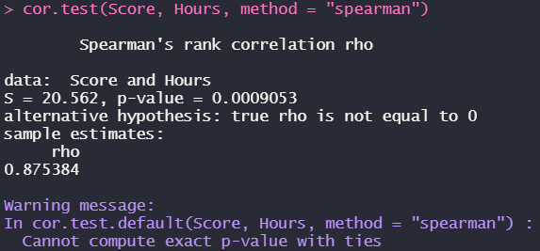

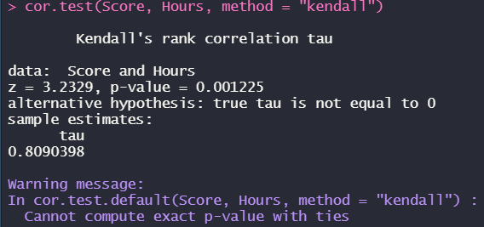

*(from all of the test results, we can see that the p-value is less than significance level, meaning that we can reject the null hypothesis and say that the correlation is nonzero)*

1. The data frame **Grades** in the **PASWR** package contains the information about the GPA and SAT scores of second semester freshman students.
2. Create a scatterplot of the data to investigate the relationship between gpa and sat scores

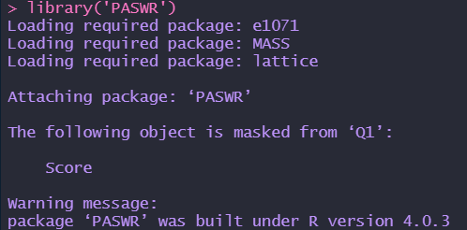

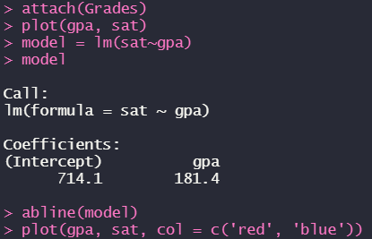

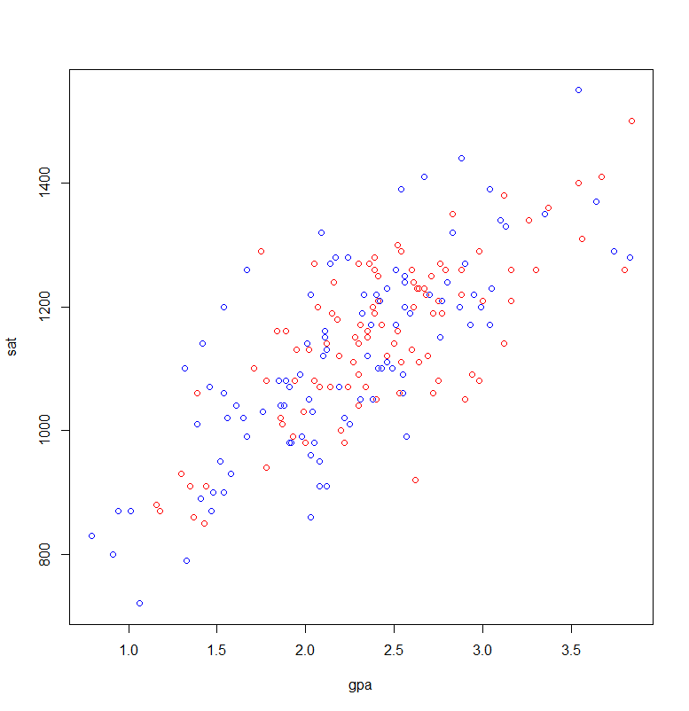

*(the relationship should be:* ***sat = 714.1 + 181.4*gpa****)*

1. Obtain the least squares estimates for  and  . State the estimated regression model.

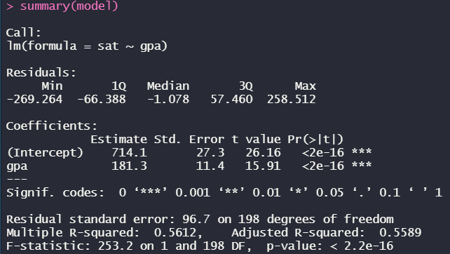

*(is intercept and is slope)*

*(the relationship should be:* ***sat = 714.1 + 181.4*gpa****)*

1. Display the regression model along with the scatterplot.



